Chuck Floyd - Chief Executive Officer
Bruce J. Moran - Senior National Security Advisor
Security Solutions Technology
National Security Report -- 01/20/2019
National Security Crisis
UNITED STATES SOUTHERN BORDER
PRESIDENT TRUMP DELIVERING ON HIS WORD
THE COMPREHENISVE BORDER LAYERED SOLUTON
Physical Barrier, Sensors, Cameras, UAV’s, Fix & Mobile Towers
Agents, Dogs, Roads, Equipment, Tech Upgrades, et al

INTRODUCTION:
BACKGROUND: SECURE FENCE ACT [SFA - 2006] - SECURING AMERICA’S BORDER ACT [SABA - 2006]. GOP Senator Majority leader Bill Frist was the major Senate mover for the SFA & SABA (2006) in protecting America’s borders along with Senior Policy Advisors Bill Wichterman, Cherie Harder, Chuck Floyd and Bruce J. Moran. Senator Frist & Chuck Floyd designed and planned the U.S. Border Security High Tech double fence/road/barriers system and adaptations [land, air & water] (top-bottom). Our team had advanced key critical strategic and tactical operations to protect our Southern U.S. border (California, Texas, New Mexico & Arizona). Major critical National Security threats have demonstrably grown. Over the last 18 years [911-attacks], several administrations and Congress have not fully addressed the severe transnational nature of the National Security threat. Tremendous pressures are placed on law enforcement and supporting services personnel where essential and critical border security needs are not met. New border security personnel must be hired. Updated hi-tech equipment is necessitated. A Comprehensive Border Layered Solution is needed for our law enforcement border personnel and supporting emergency services: including but not limited to: Customs Border Patrol [CBP], ICE, DEA, FBI, ATF, State, County & Local Police, SWAT teams, 911 center personnel, fire, local hospital services, detention/holding centers and judicial personnel/centers. President Trump is now moving this major National Security Crisis Comprehensive Border Layered Solution front and center for passage [funding] by the U.S. House and U.S. Senate.
Many thanks to President Donald Trump and DHS Secretary Kristjen Nielson for tirelessly standing up to ensure our U.S. Southern Border is fully protected.
[See Appendix A: White House Briefing
[See Appendix B: Comprehensive Layered Border Security Prototype
[See Appendix C: VP Pence on Shutdown and Border Security
BEFORE PROCEEDING TO READ THE BODY OF OUR NATIONAL SECURITY REPORT, IT IS IMPORTANT TO HOLD IN YOUR MIND, WHAT A LAYERED BORDER SECURITY SYSTEM PROTOTYPE CONSISTS OF: (President Trump’s plan is NOT just a WALL that many pundits and elected officials have said it to be): (Appendix B: Comprehensive Layered Border Security Prototype – Greater details provided in how to soundly and practically protect our U.S. Southern Border).

What does a Layered Border Security solution look like?
Below is a Layered Security Border Plan
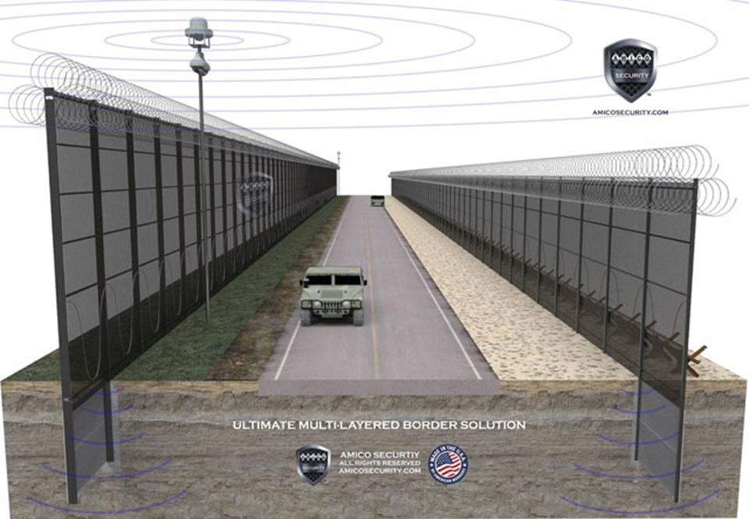

Below is the HESCO Design (Military uses in Combat Areas)
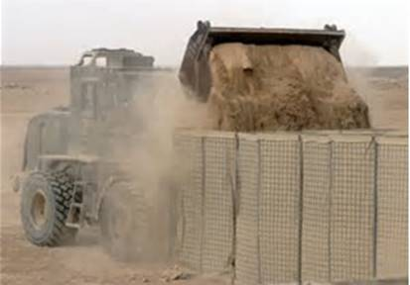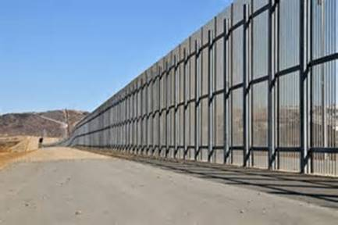
AMERICAN CITIZENS LIVING ON/NEAR THE U.S. SOUTHERN BORDER CAUGHT BETWEEN A ROCK & A HARD PLACE
LOCAL CITIZENS LIVING ON OR NEAR THE U.S. SOUTHERN BORDER LIVES MATTER: With the great on-going pressures and demands placed on border law enforcement and supporting service personnel, their requests for a proper and fitting border security program have gone unanswered. These daily pressing border problems leave local U.S. citizens holding the bag. Local residents are constantly dealing with: illegal aliens, criminals, gangs, cartels, arms dealers, children/young women traffickers, money-movers (launderers) and transnational terrorists. There is a constant high influx of illegal individuals, including caravans on the U.S. Southern border. Ports of Entry are purposefully circumvented which cause the local citizenry tremendous hardships. These U.S. citizens who live on or near [within 15 miles plus] of the Southern U.S. border have to always be on-guard and fear for their personal safety. Over the last 18 years, many U.S. border citizens, individually or collectively -- families, friends, neighbors, private entrepreneurs and tourists -- have been victims of continuous harassment, intimidation, threats and serious crimes [felonies 1st Degree Murder]. As such these illegal individuals [certain cartel hitmen] boldly and sometimes heavily armed pass through local farms & ranches, small business properties, little villages & towns and larger cities, including the U.S. government borderland, preparing themselves and/or illegal contraband to disappear into the greater United States
https://www.thenewamerican.com/usnews/immigration/item/22754-u-s-ranchers-on-border-plead-for-help-amid-onslaught-of-illegals
U.S. Ranchers on Border Plead for Help Amid Onslaught
www.thenewamerican.com

Inspiring the meeting, according to attendees quoted in media reports, was the kidnapping of a local American ranch hand. The victim reportedly happened upon a caravan of drug runners from the ...

“Smugglers and other criminals are pouring across the often undefended border… jeopardizing their [rancher’s} livelihoods and even their lives — not to mention national security. Some… lost loved ones…despite years of pleading with federal and state officials…their pleas had gone unanswered…Despite claims from politicians in Washington, D.C., it is clear that the border is nowhere close to what a reasonable person would describe as “secure.””
http://www.criminaljusticedegreesguide.com/features/the-8-most-dangerous-border-towns-in-america.html
The 8 Most Dangerous Border Towns in America - Criminal Justice Degrees Guide
www.criminaljusticedegreesguide.com

For many years, border towns were safe and attractive places for tourists to visit and get a taste of foreign culture, food, shopping and nightlife.
[El Paso (TX), San Diego (CA), Calexico (CA), Brownsville (TX), Columbus (NM), Laredo (TX), Nogales (AZ) and McClellan (TX).]
https://www.judicialwatch.org/blog/2018/05/arizona-border-ranchers-live-fear-illegal-immigration-crisis-worsens/
Arizona Border Ranchers Live in Fear as Illegal Immigration Crisis Worsens - Judicial Watch
www.judicialwatch.org

More than half a million illegal immigrants of several dozen nationalities have been apprehended on John Ladd’s sprawling cattle ranch in southeastern Arizona. Ladd has also found 14 dead bodies on his 16,500-acre farm, which has been in his family for well over a century and sits between the ...

https://www.judicialwatch.org/blog/2014/08/doj-report-nearly-half-fed-crimes-near-mexican-border/
http://www.nbcnews.com/id/45440385/ns/nbc_nightly_news_with_brian_williams/t/along-mexican-border-us-ranchers-say-they-live-fear/#.XDLr_CgVr8s
https://www.dailywire.com/news/10155/9-things-you-need-know-about-illegal-immigration-aaron-bandl

CRIMES NEAR THE MEXICAN BORDER -- UNITED STATES DOJ
“Almost 50 percent of federal crimes were committed near the Mexico border. A report from the Department of Justice (DOJ) in 2014 found the following, via Judicial Watch: ….most of the offenses were immigration related. In fact, 38.6% of all federal cases (23,744) filed last year involved immigration, the DOJ report confirms. Nearly 22% (13,383) were drug related, 19.7% (12,123) were violent crimes and 10.2% (6,300) involved white-collar offenses that include a full range of frauds committed by business and government professionals.”
Summary Of Border Arrests 2017 / 2018
Congressional Border Briefing 2019
2018 - 17,000 Adults Arrested At Border With Existing Criminal Records
2017 – 3,755 Known Or Suspected Terrorists Prevented From Entering U.S.
$2.5 Billion dollars made annually by human smuggling

“Mexican Cartels Absolutely Control the [U.S.] Southwest Border”
“The DEA says six cartels have the biggest impact on drug trafficking into the United States: Sinaloa Cartel, Jalisco New Generation Cartel (Cartel Jalisco Nueva Generación, or CJNG), Juarez Cartel, Gulf Cartel, Los Zetas Cartel, and Beltran-Leyva Organization.”
https://www.theepochtimes.com/mexican-cartels-absolutely-control-the-southwest-border-says-sheriff_2568412.html
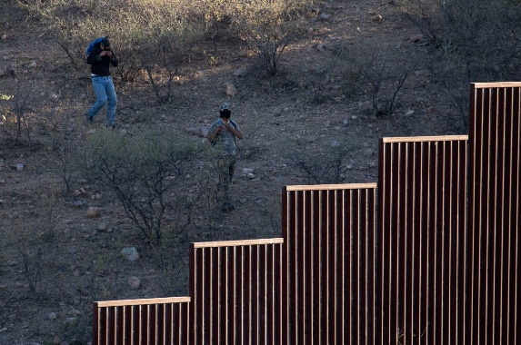 | Mexican Cartels ‘Absolutely’ Control the Southwest Border, Says Sheriff  www.theepochtimes.com  Arizona DEA Special Agent in Charge Doug Coleman at his office in Phoenix, Ariz., on May 24, 2018. (Samira Bouaou/The Epoch Times) Cartel activity in the United States is mainly overseen by ...
“Every time politicians and media discuss border security, one particular group of people is paying very close attention: Mexican cartels.” (Commentary: The Mexican Cartels Do Not Want – In Any Form Or Fashion – For President Trump To Succeed With His “Comprehensive Border Security Layered Program - It Is Not Just A Wall/Fence/Barrier – It is everything that goes along with it [Layered Border Security]– they fear and loathe full all out border security measures – the Cartels will then have to be constantly on guard, living in fear and always have to look over their shoulders. Cartels know how to exploit every weakness on the border. Cartels constantly are testing and seeking every border vulnerability point. President Trump is looking to completely turn the tables on the Transnational Narco-Terrorism Cartels -- It starts with a comprehensive border security layered program.

“Every day, every minute, some penetration of the Texas border, California border, New Mexico border, Arizona border—every minute, someone is preparing to send a load in, or traffick humans in, or some type of criminal activity is going on. Every minute of every day. That’s their job, that’s what they’re committed to do, that’s how they get paid. And that’s what we’re up against.”…“[The Cartels] maintain drug distribution cells in designated cities across the United States that either report directly to TCO [Cartel] leaders in Mexico or indirectly through intermediaries,” according to the Drug Enforcement Administration’s (DEA) 2017 national drug threat assessment.”

“The Cartel leadership in Mexico gets more sophisticated the higher up the ranks you go, Coleman said…They [The Cartel Leaders] carry 15 to 20 different cellphones, they never let anyone buy from them that they don’t know and haven’t vetted, and they’re moving constantly, “because we are always tracking them in Mexico.”
“You have to at some point pay something [to the Cartels]. Sadly, a lot of women pay with their bodies,” she said last year. “There are cases where the women—with the expectation of getting raped—prepare themselves by getting on birth control … for the purpose of the journey.”

“Cartels also pressure juveniles to transport drugs across the border; thousands of children cross the border every day to attend school.”

ISIS HEADED TO UNITED STATES
ESTIMATED 100 ISIS MEMBERS STOPPED IN GUATEMALA (2018)
DO CARAVANS POSE MULTIPLE THREATS TO
THE UNITED STATES

ISIS DIVERGENT INSIDIOUS METHODS: MEMBERS OF ISIS TRIED TO MIX IN WITH THE CARAVAN (5,000-7,000 ASYLUM SEEKERS) BEFORE LEAVING FROM GUATEMALA. GUATEMALA OFFICIALS DETAINED, ARRESTED THEN DEPORTED APPROXIMATELY 100 ISIS MEMBERS BACK TO THEIR HOME COUNTRY:
“[Guatemalan President Jimmy] Morales told Prensa Libre, a Guatemalan newspaper of record, that “we have apprehended close to 100 persons completely involved with terrorists, with ISIS and we have not only detained them within our territory, but they have been deported to their country of origin.”

https://www.newsmax.com/michaeldorstewitz/guatemala-terrorists-president-caravan/2018/10/19/id/887164/

“100 ISIS members [had been] ID'd, detained and then deported back to their own country from Guatemala. How many ISIS members did the Guatemalan government miss that crossed the Mexico border?” Did certain ISIS members: 1) stick with the caravan 2) meet up with other recent ISIS members who crossed the border 3) join forces with Cartels or other transnational terrorist or criminal groups 4) or will they quickly disappear with other ISIS members already established and embedded (network) in Mexico then sneak across the border to the U.S.

SPECIAL NOTE: U.S. Government needs to check and cross-check (find out) not only if these 100 member ISIS figures hold true, but find out each of the ISIS member’s country of origin; and the U.S. Government needs to further investigate their travel (many routes they took) to get to Guatemala (Gateway To The United States) – along with who supported such efforts.

YES, WE’VE NABBED TERRORISTS ON THE SOUTHERN BORDER
https://www.nationalreview.com/2019/01/yes-weve-nabbed-terrorists-on-the-southern border/?utm_source=Sailthru&utm_medium=email&utm_campaign=NR%20Daily%20Monday%20through%20Friday%202019-01-10&utm_term=NRDaily-Smart

(See Article Above: For 8 More Examples Of Terrorists Coming into the United States – including Mohmoud Youssef Kourani [Bribed Mexican Diplomat in Beirut] – who came over the U.S. Southern Border [in a trunk of car] then subsequently raised monies for Hezbollah Terrorists (settled in Dearborn, Michigan – Kourani convicted 2005 – giving material support to terrorists).

Sharafat Ali Khan, a Brazil-based Pakistani human smuggler, was convicted in the U.S. in 2017 of sneaking between 25 and 99 illegals from Bangladesh, Pakistan, and Afghanistan into the U.S. They traveled on foot from Brazil through Peru, Ecuador, Colombia, Panama, Costa Rica, Nicaragua, El Salvador, Guatemala, and Mexico before breaking into America via Texas and California. Khan’s clients included, the Washington Times reported, an Afghan “who authorities said was involved in a plot to conduct an attack in the U.S. or Canada and had family ties to members of the Taliban.”

Mukhtar Ahmad and Muhammad Azeem of Gujarat, Pakistan, were caught by Border Patrol agents just north of Tijuana in September 2015. The Washington Times reported that databases tied Ahmad to a suspected or confirmed terrorist. An unnamed foreign intelligence agency warned U.S. officials about Azeem as he headed towards this country. According to the Center for Immigration Studies, “both migrants were on U.S. terrorism watch lists.”

Anthony Joseph Tracy (a.k.a. Yusuf Noor) was convicted on June 4, 2010, of conspiring to smuggle aliens into the U.S. Tracy told federal investigators that Cuban diplomats used his travel agency in Nairobi, Kenya — Noor Services Ltd. — to transfer 272 Somalis from Kenya to Dubai to Moscow and then to Havana. From there, they traveled to Belize, transited Mexico, and then trespassed into America. One U.S. prosecutor complained that officials had “no idea who these individuals are that he assisted.” Tracy pleaded guilty to one count of conspiracy to smuggle non-citizens into the U.S. “ (Comment: U.S. Embassy reopened in Cuba 07/20/15. Are there further questions which need to be answered regarding Cuban Diplomats smuggling 272 illegal Somalian aliens (aiding and abetting) 06/04/10 across the U.S. Southern border? What further actions does Congress need to take with regards to the U.S. Embassy in Havana, (2018) with the sickening of 25 U.S. Havana Embassy employees (possible intense ultrasonic radiation) [ears ringing, disorientation, nausea, loss of balance]? It appears Cuba and it’s Diplomatic Corps have different ideas about setting up ‘normal relations’ with the United States and Canada (read below)?
https://news.miami.edu/stories/2018/12/findings-from-havana-embassy-phenomenon.html
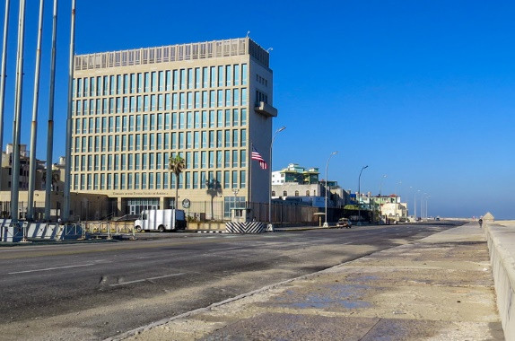 | Findings from Havana embassy phenomenon - news.miami.edu  news.miami.edu  A UM medical team has released the first report of acute symptoms and clinical findings in 25 personnel living in the U.S. Embassy in Havana. A team of University of Miami Miller School of Medicine faculty, along with collaborators from the University of Pittsburgh, today presented the first report ...
“The symptoms, which include dizziness, headaches and nausea, have been found in 10 of the 27 Canadian personnel and family members [Canadian Havana Embassy] that initially received medical testing”
https://www.theguardian.com/world/2018/apr/16/canada-cuba-embassy-illness-diplomats
Ahmad Muhammed Dhakane was a “guerrilla fighter and human smuggler who knowingly helped move into the U.S. several potentially dangerous Somali terrorists who he believed would commit violent acts if ordered to do so,” the Texas Department of Public Safety concluded. Citing federal court documents, the Christian Science Monitor reported, “At least five of his clients were supporters or members of Al Shabab or associated Somali terror groups — and at least three of them made it into the US.” (Emphasis added.) Ahmed Muhammed had been connected to Al-Ittihad Al-Islami (AIAI) and al-Barakat, both specially designated terrorist organizations.
“According to U.S. intelligence officials, al-Itihaad cooperated with the al-Qaeda operatives who carried out the 1998 United States embassy bombings in Nairobi and Dar es Salaam that killed 224 people.”
https://en.wikipedia.org/wiki/Al-Itihaad_al-Islamiya
------------------------------------------------------------------------------------------------
LARGER CRITICAL QUESTION: So by what has been described above as significant problems in protecting our U.S. Southern border -- Has each member of Congress kept their solemn oath of office?
“I do solemnly swear (or affirm) that I will support and defend the Constitution of the United States against all enemies, foreign and domestic; that I will bear true faith and allegiance to the same; that I take this obligation freely, without any mental reservation or purpose of evasion; and that I will well and faithfully discharge the duties of the office on which I am about to enter: So help me God.”

https://wtpotus.wordpress.com/2009/08/15/the-congressional-oath-of-office/
Would you say that drug cartels, ISIS terrorists, foreign terrorists and foreign gangs (MS-13) are Enemies Of The State who can or who have infiltrated deep into our country?
*6,ooo gang members (including MS 13) prevented from entering the Southern U.S. border [Congressional Border Security Briefing 2019] –
MS 13 gang members in U.S. [8,000 – 10.000] – 2018 Wiki.
https://cis.org/Huennekens/24-MS13-Members-Indicted-Maryland
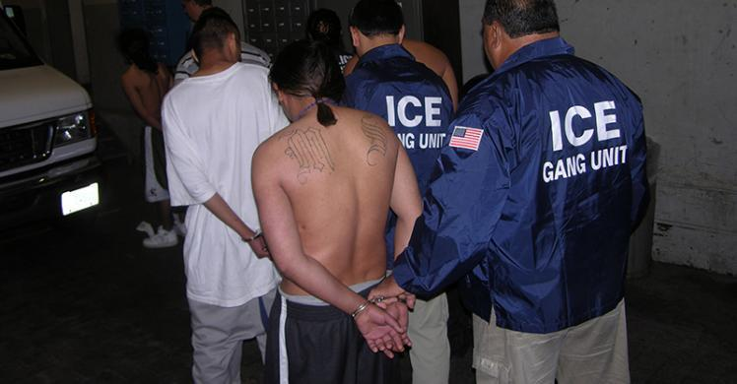 | 24 MS-13 Members Indicted in Maryland | Center for Immigration Studies - cis.org  cis.org  The Center for Immigration Studies is an independent, non-partisan, non-profit research organization founded in 1985. It is the nation's only think tank devoted exclusively to research and policy analysis of the economic, social, demographic, fiscal, and other impacts of immigration on the United States.

https://www.insightcrime.org/news/analysis/ms13-prostitution-rings-in-united-states/ (2015)
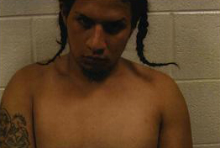 | The MS13's Prostitution Rings in the United States  www.insightcrime.org  Social workers and police officers in Maryland, Virginia, and the District of Columbia (DC) have detected at least nine child prostitution rings since 2009. Most of these networks — some of which have already been dismantled — are run by the Mara Salvatrucha, or MS13. The gang and other human ...

MS-13 YOUNG GIRL PROSTITION RINGS
VIRGINIA – MARYLAND – WASHINGTON, D.C.
“Vanessa said that she met at least seven other young girls, more or less her age, that “worked” with Rivas (MS-13). He obtained the clients by telephone, arranged the meetings, and brought the girls to the houses of other gang members, individuals or motel rooms in the DC area.” How can these MS- 13 young girl prostitution rings go on right under the noses of elected officials in Washington, D.C.; and go on right under the noses of the headquarters of our law enforcement agencies: Department Of Justice (D.C.) and Federal Bureau of Investigation (D.C.)?
U.S. CONSULATE PERSONNEL
AMBUSHED/KILLED BY CARTEL HITMEN
https://www.foxnews.com/us/suspect-arrested-in-case-of-american-killed-on-border-lake-while-riding-jet-ski-in-2010 (David Hartley Killed While On Vacation)
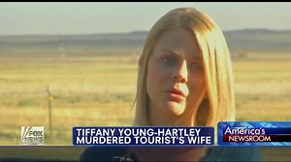 | Justice for murdered American jet skier?  www.foxnews.com  Cartel leader arrested in Mexico

https://www.nytimes.com/2010/03/15/world/americas/15juarez.html
“Mexican officials identified the couple [Executed by Drug Cartel Hitmen –Near Sante Fe International Bridge] as Lesley A. Enriquez, 25, a U.S. Consulate employee, and her husband, Arthur H. Redelf, 30, from across the border in El Paso, where he worked at the county jail [three children survived-- two children wounded – baby was in the backseat] ”
https://news.yahoo.com/explosives-attack-us-consulate-guadalajara-mexico-232111487.html [12/01/18}
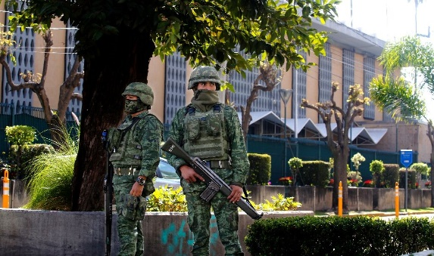 | Explosives attack at US consulate in Guadalajara, Mexico  news.yahoo.com  The US consulate in Mexico's second city, Guadalajara, was attacked with explosives hours before a visit to the country by Vice President Mike Pence and first daughter Ivanka Trump, authorities said Saturday. "The investigation has been handed over to federal authorities, who will give information

“Explosives attack at U.S. consulate in Guadalajara, Mexico …Jalisco New Generation Cartel, the powerful drug trafficking organization had threatened to attack the consulate. [Police have been said to look the other way].
AUSTRALIAN FEDERAL POLICE
FIGHTING THE DRUG CARTEL IN GUADALAJARA, MEXICO
https://en.mogaznews.com/World-News/875069/Australian-Federal-Police-fight-on-frontline-of-Mexico-drug-war-against-ice-.html
 | Mexican Drug Cartels Join Forces with Italian Mafia to Supply Cocaine to Europe | Fox News  www.foxnews.com  HAMBURG, GERMANY - MARCH 07: Packages containing confiscated cocaine are seen at a press conference on March 4, 2012 in Hamburg, Germany. Agents seized 260 kg of cocaine aboard the 'Tasman Mermaid ...
“…with a kilogram of cocaine estimated at over $63,000 in Italy, compared to the average price of between $28,000 and $38,000 in New York, the [Mexican] cartels see Europe as a lucrative and untapped market... The [Mexican – El Chapo – The Master Tunnel Digger- Guzman’s} Sinaloa Cartel is also known to have ties not only in Europe but throughout Latin America, Africa, Asia and Australia, where a booming trade has developed in the country’s cities…”

THE WALL/BARRIER/FENCE TECHNOLOGY: There is a National Security Crisis which requires a full comprehensive U.S. Southern Border Layered strategic and tactical operations plan which President Trump keeps emphasizing since his campaign days [2016] (which have not been forthcoming since our country has been attacked since 911—and Congress passed the Secure Fence Act 2006). The Crisis Readiness/Crisis Preparedness portion of our U.S. Southern Border has been grossly disregarded. Gross negligence by Congress is the term which comes to the forefront of the mind. Is it not Congress’s solemn duty to defend and protect the American people?
“All of the great leaders have had one characteristic in common: it was the willingness to confront unequivocally the major anxiety of their people in their time. This, and not much else, is the essence of leadership.”
John Kenneth Galbraith

HUMANITARIAN EFFORTS
ILLEGAL ALIENS - REFUGESS –
U.S. CONGRESS GROSS NEGLIGENCE:
(Excerpt: Congressional Border Security Briefing - 2019)*
WHAT ABOUT THE KIDS: KIDS LIVES MATTER! Mexico and the United States have never directly and properly addressed the inherent problem (neglect, abuse and suffering) with stopping unaccompanied children (refugees) 60,000 up 25% (2018)* crossing through Mexico into the Southern Border of the United States. What measures is the U.S. Congress [U.S. House Committee Foreign Affairs & U.S. Senate Foreign Relations Committee] proposing to stop unaccompanied children coming from/through Mexico certain of those children have travelled from the Honduras, Guatemala and El Salvador (making a 1,000 plus mile trek)?
U.S. Congress and the United Nations have not dealt effectively with the funding (appropriations) and treatment of people (human rights) in the Honduras, Guatamala and El Salvador.
UNITED NATIONS OFFICE ON DRUGS & CRIME [UNODC] (2019)
http://www.unodc.org/ropan/en/HumanTrafficking/human-trafficking.html
Within its mandate, UNODC for Central America and the Carribean… seeks to strengthen the existing mechanisms on border control. … The focus of the project on human trafficking and the smuggling of migrants is to strengthen international cooperation and coordination for the exchange of accurate and up-to-date information and the facilitation of mutual legal assistance for preventing and combating human trafficking and smuggling of migrants.
If this problem with human trafficking and smuggling of migrants has existed for thirty (30) plus years, how effective is the UNODC mandate? What realistic changes need to occur on the operations side of the UNODC mandate in order for the United Nations to directly address the Transnational Cartel Narco-Networks who successfully run human trafficking and migrant smuggling operations in Central America and on the U.S. Southern Border? It appears the UNODC puts a small very small patch on a very large dam. Have the Mexican Cartels effectively taken power and control over most matters on the ground as it relates to human trafficking and migrant smuggling rendering the UNODC to only be an ineffective mouthpiece to Prevent, Suppress and Punish Trafficking in Persons, especially Women and Children?
Does this “seeks to” with the UNODC sound familiar with the way Congress “seeks to” secure our U.S. borders --- for the past 18 years? How many “seeks to’s” are needed before our U.S. Southern border is soundly secured? President Trump does NOT “seek to” secure the U.S. Southern border.
President Trump Has Directly Acted To Properly and Fittingly Deal With A COMPREHENSIVE Border Layered Security PLAN for our U.S. Southern Border only to be met with great opposition and resistance from Congress who “seeks to’ move politically on the U.S. Southern border since the SECURE FENCE ACT was signed into law (2006) by President George W. Bush..
(SEE APPENDIX A: WHITE HOUSE FACT SHEET)

CARTELS – U.S. CONGRESS GROSS NEGLIGENCE:
What happened to Congress’s Solemn Duty
To Defend and Protect The American People?
What would be considered “gross negligence” on the part of Congress by failing to act [cut off a significant portion] on the U.S. Southern border dealing with the expansion the Cartel operations and business – which has greatly expanded in the United States since 2001 creating a heroin (opiod) epidemic in the last 5 years along with the increasing on-going crack/cocaine and meth [ice] epidemic/crisis? This is not only a War On Drugs but a War On The Average American Citizen Waged By The Cartels. These multiple sophisticated highly bankrolled (tens of billions of dollars plus (see below) Cartels, work alone or in concert, creating constant daily strife (trials & tribulations) bringing untold havoc, mayhem and heinous crimes throughout the United States and around the world (transnational Narco-Terrorism--growing production/manufacture and distribution of illicit drugs).

ILLICIT DRUGS IMPACT 10 YEAR COSTS = $ 5 TRILLION
[12 YEARS SINCE SECURE BORDERS ACT 2006]
VERSUS PRESIDENT TRUMP’S INITIAL REQUEST 2018/2019 OF
20 BILLION DOLLARS FOR BORDER PROTECTION:
WHAT IS THE ‘REAL’ DOLLAR COSTS BORN UPON THE AMERICAN PEOPLE BY NOT FUNDING THE COMPREHENSIVE U.S. SOUTHERN BORDER LAYERED PROTECTION PLAN OF PRESIDENT TRUMP: The illicit drug trafficking in the United States costs $500 billion* plus dollars annually – in ten years that is 5 trillion dollars – SECURE FENCE ACT WAS PASSED 2006 WHICH AMOUNTS TO AROUND $6 TRILLION DOLLARS (ILLICIT DRUG COSTS). If PRESIDENT TRUMP HAS GIVEN AN INITIAL SOUND $20 BILLION DOLLAR FIGURE [SUPPORTED BY U.S. BORDER PATROL] for overall border protection (Wall/Fence/Barrier, Personnel, Judicial support, Humanitarian Relief, Technological updates, et al) then there is SOMETHING VERY WRONG with the picture with NOT IMMEDIATELY FUNDING THE ENTIRE U.S. SOUTHERN BORDER. THE ENTIRE U.S. 2018/2019 ANNUAL BUDGET EXCEEDS 3 TRILLION DOLLARS.
*500 billion from President Trump’s Address 01/08/19
LIVE 3 HOUR DEBATE [NOT SOUND BITES - BJM]:
U.S. BORDER PATROL AGENTS/BORDER RANCHERS
& SENIOR ELECTED OFFICIALS

It appears a live national debate needs to immediately take place [with pictures – graphs – illustrations – personal encounters] between the Senior elected officials -- without ear devices [not their staff or media intermediates] who oppose immediate funding for the U.S. Southern Border versus the Border Patrol Agents who ‘actively’ patrol [and ranchers whose lives are on the line every day on] the borders who immediately support the U.S. Southern Border being comprehensively protected [top to bottom]. American citizens need to directly hear from the people who have to daily deal [CBP AGENTS/RANCHERS) and make decisions [ELECTED OFFICIALS] with regards to the major National Security problems of the U.S. Southern Border.
https://www.cdc.gov/mmwr/preview/mmwrhtml/mm6450a3.htm
CDC excerpt” The United States is experiencing an epidemic of drug overdose (poisoning) deaths. Since 2000, the rate of deaths from drug overdoses has increased 137%, including a 200% increase in the rate of overdose deaths involving opioids (opioid pain relievers and heroin). … During 2014, a total of 47,055 drug overdose deaths occurred in the United States, representing a 1-year increase of 6.5%, from 13.8 per 100,000 persons in 2013 to 14.7 per 100,000 persons in 2014.
Drug Cartel Impact: We must first acknowledge the Cartel leaders are wise and seasoned business people who have been running extensive drug/arms operations and money laundering (money-mover) operations for several generations. The Cartels thrive in the black market, underground economy, informal and formal markets (establish legitimate businesses). They are deeply embedded into cities and towns all throughout the United States. * (See: No. 2 San Diego (CA) – El Chapo Example: Immediately Below) The Cartel leaders know how to circumvent the Rule Of Law and astutely counter law enforcement. They subvert our legal and criminal justice system with ease and do it extremely well. The Cartels drug dealing operations are widespread. Their drug dealers are extremely street savvy. President Trump has taken up the direct challenge to make inroads into the nefarious activities of the Cartel international narco-terrorism world-wide networks. We need to first start an American Citizen Safety & Security First “Law & Order” Initiative with our own borders and clean-up our own crime ridden U.S. streets. We either fully back President Trump in this critical, sound and germane Comprehensive National Security Layered U.S. Southern Border program or watch our society fall from within. Politics and personal feelings must be put aside or we suffer the ravages of watching our family, friends and neighbors suffer and die as our society further deteriorates right in front of our own eyes within our lifetime.
8 Most Dangerous Border Towns (2015)
- El Paso (TX)
- San Diego (CA)
- Calexico (CA)
- Brownsville (TX)
- Columbus (NM)
- LAREDO (TX)
- 7) Nogolas (AZ)
- McAllen (TX)

http://www.criminaljusticedegreesguide.com/features/the-8-most-dangerous-border-towns-in-america.html
For many years, border towns were safe and attractive places for tourists to visit and get a taste of foreign culture, food, shopping and nightlife.

The Crisis on Our Southern Border
Q: Do walls really work? Isn’t this a “medieval solution for a modern problem”?
A: Walls work. Congressional Democrats, who risibly claim that a wall won’t because it’s a “medieval solution” to a modern problem, should try making the same argument about the wheel. The data shows that anywhere we have built walls with the correct mix of personnel and technology, we have seen a massive drop in illegal crossings – usually by 90% or more.
- San Diego (built in 1992): Apprehensions of illegal aliens crossing the border dropped 92% over the past 23 years
- El Paso (built in 1993): Apprehensions of illegal aliens crossing the border dropped 72% in one year and 95% over 22 years
- Tucson (built in 2000): Apprehensions of illegal aliens crossing the border dropped 90% over 15 years
- Yuma (built in 2005): Apprehensions of illegal aliens crossing the border dropped 95% over 9 years

Q: Is the President being unreasonable in his request? Is he refusing to compromise?
A: No. President Trump has asked Congress to fulfill its solemn duty to protect the American people and provide the needed funding to secure the border. The frontline men and women of the U.S. Border Patrol have long said they need border barriers and it’s up to Congress to deliver. The President has already shown he is willing to compromise by agreeing to a steel barrier along the border rather than a concrete one. Congressional Democrats must decide if they will continue to prioritize partisan politics and their desire for open borders over supporting a mainstream, common sense solution to keep our country and our people safe.

Q: Are walls immoral?
A: No. It’s unclear why Nancy Pelosi and other prominent Congressional Democrats believe that a border wall is “immoral” while other physical barriers, which Democrats have repeatedly voted to fund, are not. It is also interesting that Congressional Democrats have made no similar outcries over the “immorality” of border walls erected by other nations, such as the walls in Jordan, Israel, and the Vatican.

Q: Aren’t these migrants seeking asylum from dangerous conditions?
A: Most asylum claims made by migrants arriving from the Northern Triangle of Central America (i.e. Guatemala, Honduras and El Salvador) have proven to be meritless. That’s because widespread knowledge of loopholes in United States immigration—namely the low threshold screening standards to claim asylum— have enabled migrants to fraudulently claim “credible fear” and be released into the United States. Due to the low bar for credible-fear, DHS is seeing applicants—well-coached by coyotes, advocates, and others—utter the “magic words” to gain entry into American communities.
- Over the last five years, DHS has seen a 1,750% increase in credible fear claims for aliens who have been placed in expedited removal.
- The total number of credible-fear referrals for interviews increased from about 5,000 a year in FY 2008 to about 100,000 in FY 2018.
- Over the last ten years, there has been a 300% increase in aliens placed in expedited removal from the Northern Triangle. 89 percent of aliens from the Northern Triangle with a credible fear finding are found to have positive credible fear, yet only nine percent of the cases completed in FY 2018 were ultimately granted asylum.
- NOTE: Not only is economic migration not a legitimate grounds for asylum by law, but migration has steadily increased even though the conditions in many of these countries have been steadily improving. Homicide rates in Honduras have been cut in half since 2012, and Guatemala’s are at their lowest level since 2000. El Salvador has seen enough job growth in recent years to justify the return of those who were unable to come home after earthquakes in the 2000s.

Q: What other evidence do we have that these asylum claims are not meritorious?
Mexico is generously offering all migrants asylum, work permits, and a specific job. Nevertheless, migrants have turned down this offer with the stated intention of reaching the United States for economic opportunities. A significant percentage of those migrants claiming to be seeking asylum fail to appear for their hearings before an Immigration Judge and subsequently disappear into the interior of the United States.

Q: Are criminals coming across the border?
In Fiscal Year 2018, CBP arrested 17,000 individuals with criminal records. On a typical day, CBP apprehends 21 wanted criminals at our Southern Border. The officers and agents must be vigilant about identifying national security and public safety threats above all others and denying entry to those who might do us harm.
Criminal aliens in the interior of the country is an issue as well. In the last two years alone, ICE officers made 266,000 arrests of aliens with criminal records – including those charged or convicted of 100,000 assaults and nearly 30,000 sex crimes.

Q: Is the crisis at our border fueling our nation’s drug epidemic?
Our porous southern border has allowed drugs to flood into our country and endanger the security and well-being of American communities. Mexico is the source of more than 90 percent of wholesale heroin seized by law enforcement in the United States, up from only 10 percent in 2003. The amount of fentanyl seized by Immigration and Customs Enforcement (ICE) in FY 2017 (2,370 pounds) was enough to kill every American citizen by overdose.

Q: Does the crisis at our border pose a terror threat?
Overall, DHS stops on average 10 individuals on the terrorist watch list per day from traveling to or entering the United States—and more than 3,700 in Fiscal Year 2017. Most of these individuals are trying to enter the United States from points abroad by air, but we must also be focused on stopping those who try to get in by land. Additionally, last year at our Southern Border, DHS encountered more than 3,000 “special interest aliens”—individuals with suspicious travel patterns who may pose a national security risk—not to mention the many criminals, smugglers, traffickers, and other threat actors who try to exploit our borders. This threat isn’t new. In 2016, President Obama’s DHS Secretary Jeh Johnson ordered that DHS form a “multi-DHS Component SIA Joint Action Group” to drive efforts to “counter the threats posed by the smuggling of SIAs.” Just this month, the House Homeland Security Committee released a report outlining the threat posed by SIAs, as well as unknown and other potentially dangerous individuals, traveling to the United States using illicit pathways.

Q: Isn’t illegal immigration down?
Some media figures, who do not understand loopholes in United States immigration law, have tried to argue that because illegal borders crossings are lower today than in previous years, that we are not experiencing an illegal immigration crisis. That argument is wrong.
Fiscal Year 2000 | Fiscal Year 2018
In FY 2000, CBP apprehended 1.6 million migrants attempting to illegally enter the United States. | In FY18, CBP apprehended 400,000 migrants attempting to illegally enter the United States
In FY 2000, 98% of CBP apprehensions were Mexican nationals. | In FY18, 56% of CBP apprehensions were Central American
In FY 2000, CBP apprehensions were primarily single adults and, as such, 95% of apprehensions were repatriated within hours. | In FY18, well over a third of all illegal migrants apprehended by CBP were family units or unaccompanied minors (i.e. are individuals for whom DHS cannot deliver legal consequences and who are instead released into the United States interior).
The critical Difference between illegal border crossings in 2000 vs. today is that, in 2000, the vast majority were Mexican single adults, and, as such, those entering illegally were detained and repatriated to their home country within hours. Today, DHS is experiencing an influx of illegal migrants for whom it cannot deliver legal consequences (i.e. minors and adults who arrive with minors). As such, rather than detaining and removing these individuals, DHS simply catches them and then releases them into American communities.

• In December, DHS averaged 2,000 illegal entries a day at the Southern border.
• Fiscal Year 2018 is the highest number of family unit apprehensions on record – it is more than 40% higher than any previous year on record.
• It takes DHS one year to remove the number of family unit migrants that cross our border illegally every three days.
• To demonstrate the nature of the problem. Of the illegal alien apprehended in FY17:
o 82% of single adults had been repatriated
o 91% of Mexican single adults had been repatriated
o Only 1.1% of non-Mexican family unit aliens had been repatriated
o Only 1.8% of non-Mexican unaccompanied alien minors had been repatriated.
▪ i.e. of the 31,754 unaccompanied minors CBP apprehended from the Northern Triangle in FY17, 98.2 percent remain in the country today.

Q. How does our porous border endanger the well-being of migrant children?
A: Aliens know generally that if they bring ANY minor with them they will be apprehended by Customs and Border Protection and released into the interior of the United States. This well-known loophole acts a magnet for family units and entices smugglers to use children as a way to gain access to the United States by posing a family unit. In the last two months, DHS has seen an over 100 percent increase in fraudulent family units at the Southern border (538 in the last two months, compared to 507 the five months prior to that) Additionally, we see NINE fraudulent family units each day. The result of these loopholes is that smugglers and illegal migrants know that if they arrive in the United States illegally under the age of 18 (or arrive with someone else under the age of 18), they can benefit from catch-and-release and then disappear into the interior of the country.

Q. What are we doing to combat the humanitarian crisis at our border?
Congress must secure the border in order to stop the humanitarian crisis at our border. Loopholes in United States immigration law encourage parents to send their children alone on a dangerous journey to the United States, often at the hands of unscrupulous human traffickers. Data shows that 31% of women and 17% of men are sexually assaulted along the journey. Additionally, 68% of migrants and refugees are victims of violence along the journey.

APPENDIX B: What Does A Layered Border Security System Look Like?

(A Layered Security Border System)

American citizens want national security, but they do not know what a “Wall” means as it is referenced in border security. A wall is only one part of a layered security solution.

The U.S. Customs and Border Protection (CBP) Office of Border Patrol is responsible for securing the U.S. border between the ports of entry. The authority for this is based on the Immigration and Nationality Act 287(a)(3) and copied in 8 Code of Federal Regulations (CFR) 287 (a)(3). Department of Homeland Security and the Border Patrol has a primary mission to prevent terrorists and weapons of terrorism from entering the United States and also to detect, interdict, apprehend, and detain those who attempt to illegally enter or smuggle any person or contraband across the nation’s borders. CBP has divided geographic responsibility for the southwest border among nine Border Patrol sectors. Each sector has a varying number of stations, with agents responsible for patrolling within defined geographic areas.

Our national border security requires layered security solutions that include a physical barrier, sensors, cameras, UAVs, fixed & mobile towers, dogs, agents, roads, and equipment. A physical barrier, fence, or wall is a key ingredient of a layered security solution. This type of layered security solutions are used by the military in order to provide security in combat situations. Our southern border is more dangerous than borders in Iraq or Afghanistan.

In 2010, DHS Secretary Janet Napolitano ordered the redeployment of $50 million of Recovery Act funding to other “tested,” commercially available security technology, including mobile surveillance, thermal imaging devices, ultra-light detection, backscatter units, mobile radios, cameras and laptop computers for pursuit vehicles, and remote video surveillance system enhancements, along with a wall or fence. “Not only do we have an obligation to secure our borders, we have a responsibility to do so in the most cost-effective way possible,” Napolitano said.

What does a layered security solutions look like?

The below chart demonstrates that the U.S-Mexico border could “absolutely” be secured, with undocumented immigration reduced to near-zero levels. The network of fences, walls, and electronic surveillance that CBP has erected along its Yuma sector of the border to stop illegal immigration from Mexico reduced apprehensions. The part of the border system made up of observation towers can be kept augmented by smart fencing, cameras, and other surveillance equipment where migrants could be detected before they reach the border and intercepted with security forces.

There are nine CBP Sectors along the southern border and the below chart demonstrates how many illegals are identified and detained coming across the border. Only a small percentage of illegals are apprehended by CBP, the rest vanish into the U.S.
The cost of a layered security solution along our southern border is $30B.

The cost of illegal immigration to the American taxpayer for one year is over $200B. This cost includes funds spent for medical services, schools, courts, jails, police, fraud, welfare, remittances, low-wage jobs, etc. American citizens are killed, raped, robbed, assaulted, and their identities are stolen by illegal immigrants.

The Return on Investment (ROI) of building a layered security solution across our southern border pays for itself within two months. With this type of investment, why are Democrats against building a wall or fence, along with layered security? It is all about 2
Their potential voters, power, and the 2020 election.

All American taxpayers must support President Trump in his effort to build the wall and sign new legislation that creates a comprehensive immigration policy that is good for America, not the Democrat Party.

APPENDIX C: Vice-President Pence (01/16/19)
Vice President Mike Pence: "Democrats refuse to compromise on border wall funding to end the shutdown."

"America has a national security and humanitarian crisis at our southern border, and President Donald Trump has promised to end it. We’ve already taken important steps, but rather than work with us to make further progress, Democrats in Congress have refused to compromise on the wall, leading to the longest shutdown in U.S. history. The American people deserve better...."
"President Trump and I recognize that border security is national security. That’s why this president has made it a priority to end this crisis, secure our border, build a wall, and protect the American people...."

"But the American people deserve to know: Democrats refuse to negotiate on building the wall. Even as we face a crisis on our southern border, and as 800,000 federal workers go without paychecks, Democrats in Congress have been unwilling to seriously discuss even partial wall funding. President Trump and our administration will not be deterred by the Democrats' obstruction. The American people want to see action, and we intend to deliver.

It’s time for Democrats in Congress to do their job, negotiate in good faith, and reach an agreement that ends the humanitarian and security crisis at our border and reopens the government. The American people deserve nothing less."

Chuck Floyd/ Bruce J. Moran
---- END NATIONAL SECURITY CRISIS REPORT ----

